Purchasing and Accessing Your Practice Exams via GMetrix

Steps for Purchasing
- Navigate to one of the links below to access the purchase page.
  - For CAPA: https://www.gmetrix.com/Products/Details/ABPANC-CAPA
  - For CPAN: https://www.gmetrix.com/Products/Details/ABPANC-CPAN
- Click the Add to Cart link
- Click the Login button at the top-right corner of the page
- If you don’t have an account yet, click the Sign up here! Link at the bottom of the page. Otherwise, log in to your GMetrix account.
- Once logged in, navigate to your cart by clicking the icon at the top-right corner of the screen
- Enter your billing information and click Review your Order.
- Confirm your purchase and you will be taken to your account page.
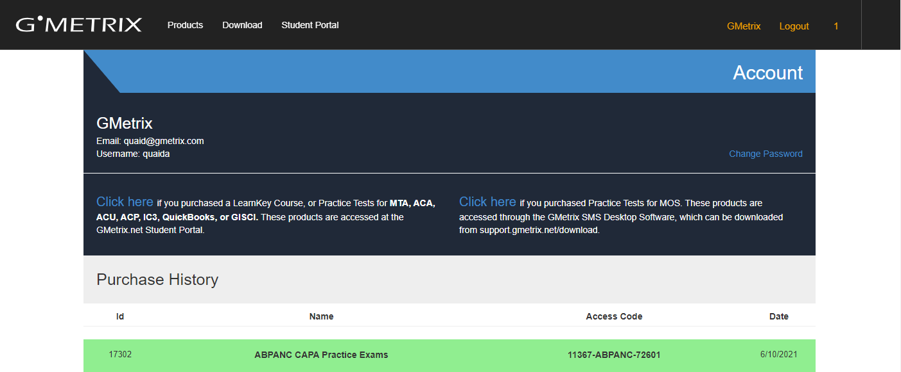
  - Note: you can access the account page at any time in the future by logging into www.gmetrix.com and clicking on your name in the upper-right corner

- Copy the Access Code from the table at the bottom of the page. You will need to redeem it momentarily.
- Navigate to www.gmetrix.net and log in to your account.
- You will be prompted to enter an Access Code on the dashboard. Paste the code you received on your gmetrix.com account page and click Redeem.
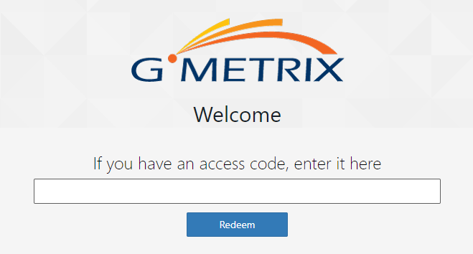
  - You can redeem additional Access Codes in the future by clicking the Redeem option in the left navigation menu

Accessing Your Practice Exams

Getting Your Certificate
You will be able to access your ABPANC practice exams in two ways within the GMetrix system, the Practice Exams Course and the Training Mode Tests. In order to obtain your Certificate of Completion, you will need to complete the CAPA/CPAN Practice Exams Course within the system. You can access the course by selecting Courses from the left navigation menu and locating it on the Select a Course page.
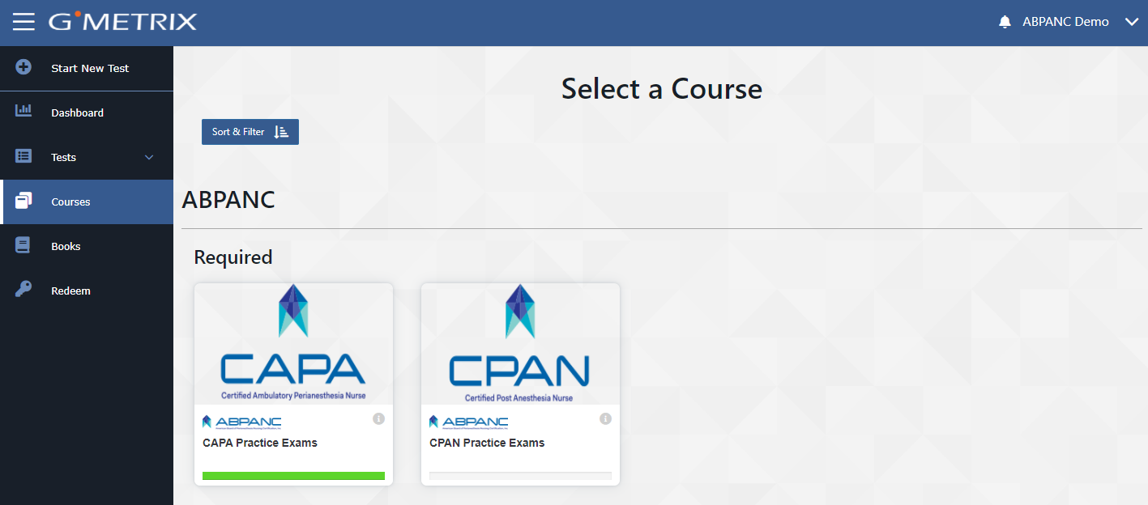
This course requires that you complete all four practice exams within the time limit provided with a score of at least 75%. Once all four exams have been completed, you will need to complete the ABPANC End of Program Survey and sign an attestation that you have fully completed the survey. Once this is done, the Certificate icon at the top of the page will be unlocked and you will be able to view and print your certificate of completion.

Studying with Training Mode
If you’re having difficulty passing your course practice exams, you can also utilize Training Mode to help you review. To access the Training Mode practice exams, select the Start New Test button from the left navigation menu. From here, you will select the ABPANC category and then choose either CAPA or CPAN. This will provide you with a list of which practice exam you’d like to attempt.
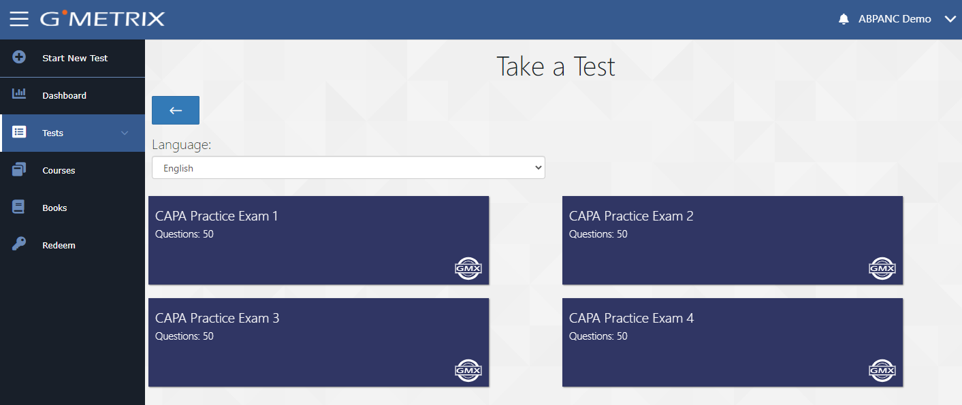
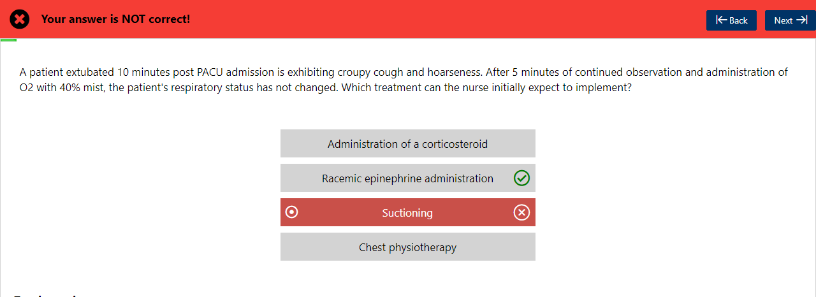
In Training Mode, you will get feedback between each question indicating whether you answered correctly as well as what the correct answer is. You can use this mode to review all of the questions in the practice exam before making another attempt.

Viewing Past Test Attempts and Reviewing Missed Questions
You can review all past test attempts you have made, either in the Course or in Training Mode, by selecting the Tests > Completed Tests item from the left navigation menu.
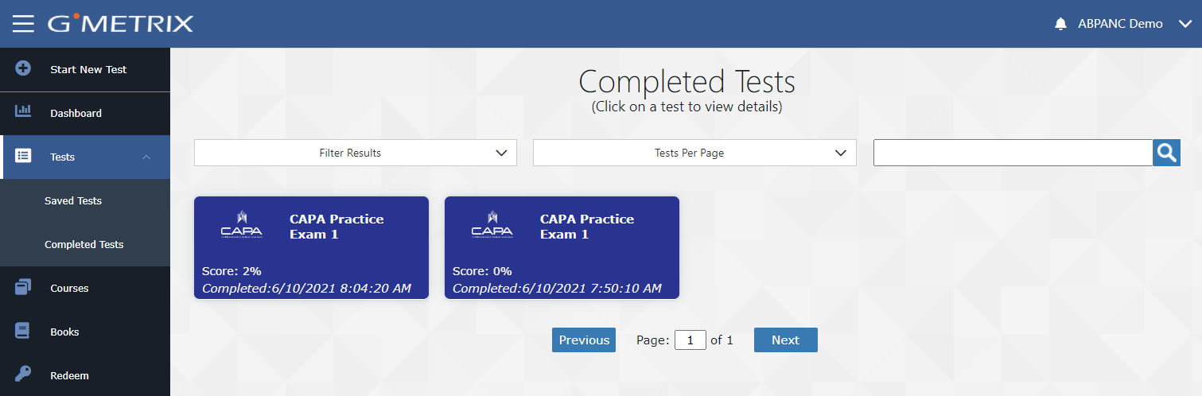
Here you can view a score report of how you did on the test, which questions were missed, and how you performed in each exam objective.
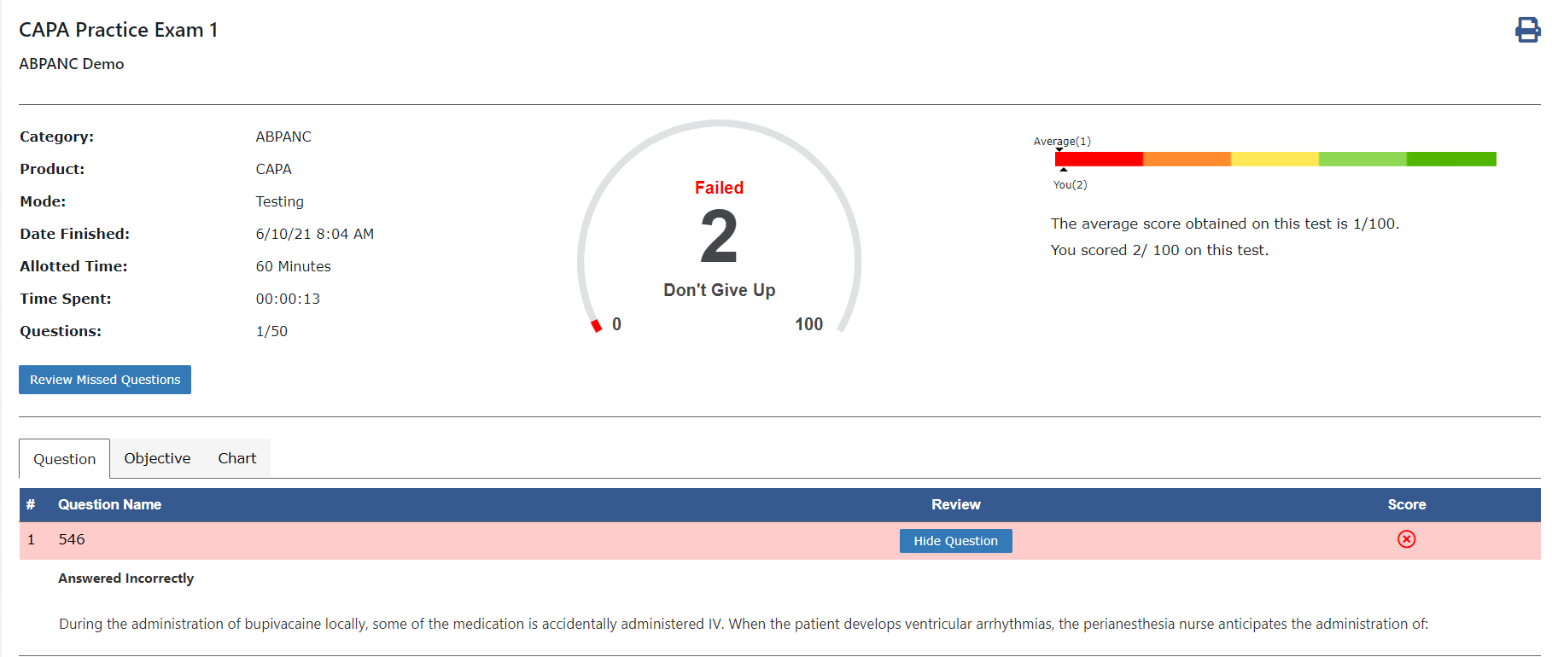
You can also select the Review Missed Questions button to quickly launch a Training Mode test that includes all of the questions you missed on that test attempt. This is a particularly good way to review the specific questions you may have struggled with when attempting to complete your Course.

